Strategic Plan
2016 - 2020

VISION
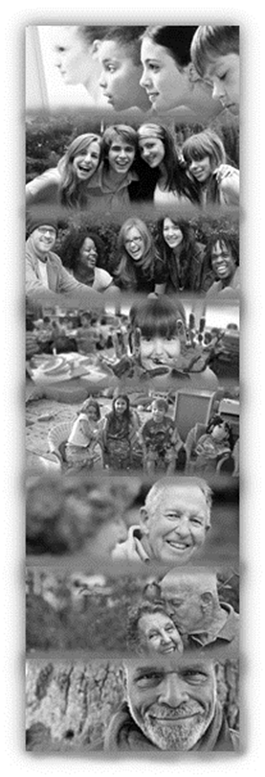
Bedford as a place where everyone has pride in their community and is inspired and supported in realising their potential
The Harpur Trust is a local foundation that uses the legacy of Sir William Harpur, who founded the Trust in 1566, to benefit the inhabitants of the Borough of Bedford through the promotion of education; the relief of poverty, sickness, hardship or distress; and the provision of recreational facilities with a social welfare purpose.
Why is this our Vision?
We believe that everyone has their own potential, which when realised will improve the quality of their lives and the lives of those around them. We recognise that there are many barriers that prevent people from achieving their full potential in life; in particular the lack of access to opportunities for learning and personal development whether caused by poverty, location, ethnicity, fear, adverse circumstances, prejudice, poor health or personal circumstances.
Our Vision helps us to articulate and communicate with the wider world that we believe we have a role to play in overcoming these barriers in order to improve the life chances for all, build a stronger community, and make Bedford a truly inspirational place to be.
Bedford – because this is our area of benefit and this is our focus for making a positive impact.
Everyone – because we want to be inclusive. All individuals should be able to access and benefit from the work we do, where appropriate, and the whole community benefits if everyone is included.
Inspired - because we want to give people the confidence and the encouragement they need.
Supported – because we want to help people to overcome barriers to success.
Realising their potential – because we want everyone to be able to identify and maximise their potential.
Pride in their community – because we want Bedford to be a ‘special place’ where people can fulfil their potential and thus help to create stronger communities, which will break down barriers for future generations.
We recognise that our goals are likely to overlap with what many others are striving to achieve, at national and local level. We don’t think the goals of supporting individuals and communities are exclusive to any one organisation or type of organisation and we are committed to using our resources to work in partnership with others wherever possible to achieve our mutual goals.

MISSION

Breaking down barriers | Providing support via grant funds to organisations and individuals where needed, involving people in local initiatives, reducing barriers caused by disadvantage and increasing the community’s access to recreation.
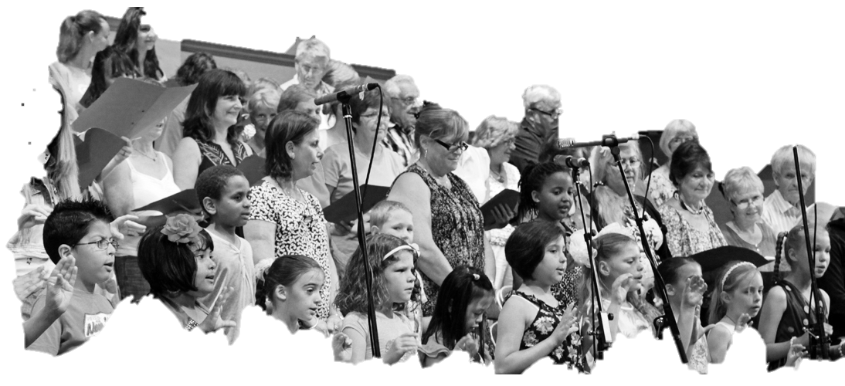  Creating opportunities | Providing individual support and developing access to learning programmes in all communities in Bedford, through grant funding and in partnership with other organisations
Providing education | Promoting the highest quality, well-rounded education, through excellence in our own schools; promoting wider excellence in education through grant funding; supporting the Bedford Academy and other maintained schools; and maximising access to our schools for the economically disadvantaged.

In all of these we aim to extend programmes and develop initiatives and activities which will be inspirational and set examples and models for
successful social policy in other areas.

VALUES

Our work is based upon our values |  | Our behaviour – examples of what our values mean in practice
We are innovative and forward looking |  | We will be alert to changes in need, be positive about change and moving forward to achieve our Vision and Mission.  We will pilot innovative projects and be passionate about communicating and celebrating successes so they can be taken further by others.  We seek to infuse our staff, pupils and beneficiaries with a sense of what they can do to make a positive difference in Bedford and the wider world.
We are caring, fair and respectful |  | We will treat staff, pupils and beneficiaries transparently and with fairness and respect.  We will promote a positive working environment, with clear boundaries and decision making processes.
We are open and outward looking |  | We value the contribution others can make and we will take time to consult and listen to their views.  We are responsive to requests for support, and welcome ideas and suggestions for developing what we do.  We want beneficiaries to be involved in shaping what we do, and we will look at how to make this easier for them.
We act with integrity, and believe in quality and effectiveness |  | We will be clear, honest and accountable for our work, through our Annual Report and Accounts.  We will set high standards for ourselves in terms of service delivery.  We will make the best use of the resources available to achieve our goals in a business-like manner.
We are inclusive |  | We promote diversity and equality of opportunity for our staff and beneficiaries alike in an open and fair way.  We are consistent in our approach, and we will identify and attempt to overcome barriers to equality whenever they appear.
We are socially responsible |  | We will always consider the impact of our work on the community around us.  We will try to make a positive and lasting difference to society.  We will be aware of the wider environmental impact of how we work.  We will promote positive environmental awareness in the services we deliver.

STRATEGIC PRIORITIES – 2016 to 2020

The trustees have identified the following strategic priorities for the next five years.

- Focus on grant making
The Trust’s grant making programme will be refined and focused, in order to deliver the greatest possible benefit to the local community.
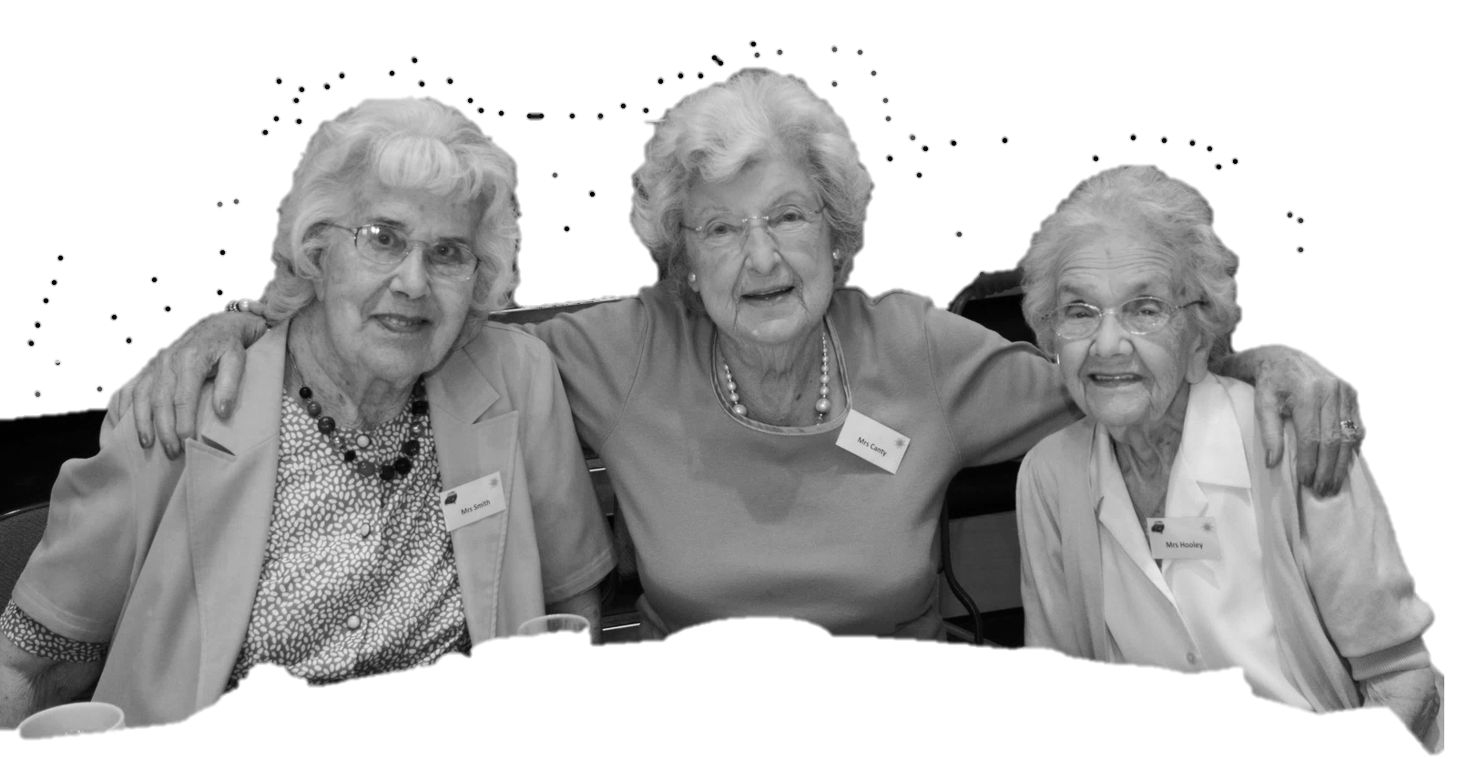
- Social investment
The trustees will develop and implement a programme of social investment, using some of its endowment capital, to further its charitable objectives, in order to enhance its impact within the community.
- The Trust’s schools working together in education
The trustees wish to increase the cooperation between its own schools in areas of education and administration, in order to improve the delivery of benefits to pupils and parents, whilst maintaining the individual character and ethos of the schools.
- Develop the Trust’s role as Sponsor of the Bedford Academy
The Trust will widen and deepen its role as Sponsor of the Bedford Academy, in order to build on the Academy’s success and secure further improvements for its pupils and their families.
- The Trust’s schools in the community
The trustees wish to build upon the existing activities of its Schools within the local community, in order to deliver even greater impact and public benefit.

