Have a go with Harpur is back!
Exhibitor Pack
Sunday 19th May 2019 11am – 4pm Bedford Park, Bedford

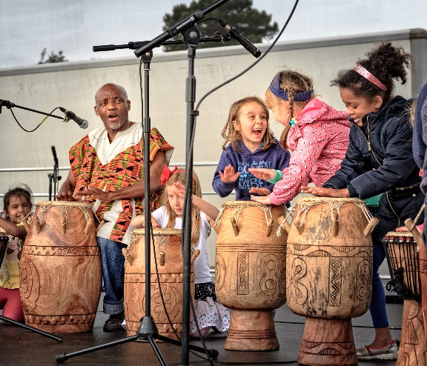 | 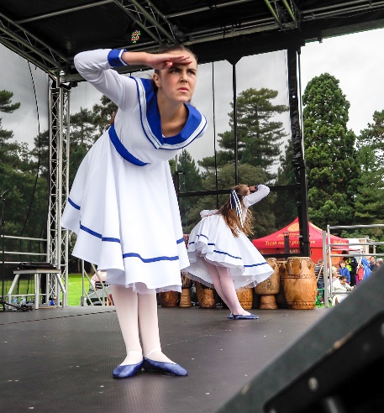

Information about the event
The theme once again is wellbeing, promoting both physical and mental health by encouraging people to try new activities, hobbies and sports and raise awareness of different community groups and clubs.
We will be providing a variety of FREE activities for the public to try including a climbing wall, a mobile potholing unit (the Traveller Cave), goal scoring and the Terminator Turmoil inflatable assault course, as well as a variety of giant board games and more (specifics to be confirmed).
We will also be providing a stage (8x6m) to enable local dance groups, sports groups and community choirs to show case their work.
This event provides a platform for many of the organisations we work with and indeed fund, to gain publicity and PR exposure, and to provide them (and us) with an opportunity to meet the public on a face to face basis.

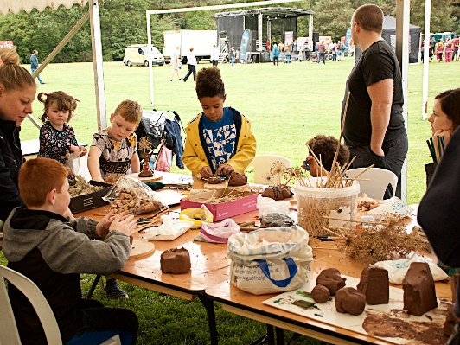 | 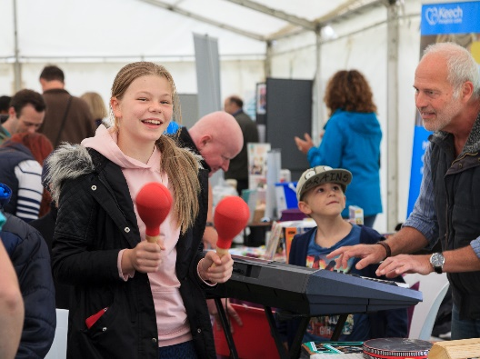 | 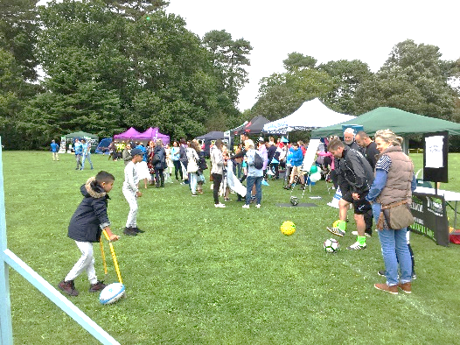

Exhibitor Marquee / Marquee 1
A focal point of the event will be our exhibitor marquee and we would like to invite local community groups, charities, arts and crafts groups and organisations to have a stand in the marquee and prices are as follows:
Space (includes table & 2 chairs) |  |  | Non-Charities |  | Charities
1m x 2m |  |  | £50 |  | Free
Activity Marquee / Marquee 2
Space (includes table & 2 chairs) | Non-Charities | Charities
2m x 3m | £75 | Free

Outdoor pitches
Further pitches are available outside of the marquee for those exhibitors with their own gazebo/marquee. We regret that we are unable to provide gazebos.
Size (includes table & 2 chairs) | Non-Charities | Charities/voluntary groups/not-for-profit
4m x 4m | £120 | Free
6m x 6m | £200 | NA
Pitch Information
The pitch sizes/dimensions represent the maximum amount of space available to exhibitors. All gazebos/stands/mobile display units should fit within the space allocated. Unfortunately, vehicles cannot be parked behind the stand and must be removed from the site and parked in the car park as soon as the stand has been set up and no later than 9.30am.

Catering
We regret that we are unable to provide catering for exhibitors but there will be 3 food stalls with reasonably priced food plus a tea and coffee stall (in addition to the Pavillion café)

Electricity on site
We will have one generator available for the marquees, so electricity is very limited. If you require an electrical socket this must be requested in advance.
Stage and arena demonstrations
We will provide a stage and we have a number of slots available during the day should you wish to show case your group. There is no charge for this but places are limited so please book early to avoid disappointment.
Up to 3 announcements during the course of the day | £30
Half hour slot on stage to offer a demonstration | Free (subject to availability)
Activity on adjacent Football pitch | Free

We encourage exhibitors to run their own competitions or raffles with an appropriate prize (such as a free taster session or sports equipment). However, we would ask that these are either free to the public or that any proceeds are donated to a local charity. Exhibitors may also wish to offer some sort of service on the day; for example, free health checks, equipment checks.
Set up and dismantle
A detailed set up / safety pack will be provided ahead of the event.
Marketing of the event
We have established excellent links with local press and will be actively targeting local newspapers, community magazines, radio and television with press releases, and we will also advertise in local print media.
There will be extensive social media and online campaigns in the months prior to the event.
Flyers and posters will be distributed to schools, businesses, cafes, retail outlets and industrial units across the Borough as well as to the numerous local charities and organisations which the Trust works with and supports and we will provide electronic and printed flyers to all participants to enable you to display and send out to your contacts.
Our own 4 independent schools, with some 3,600 pupils, will also be targeted; these parents are typically AB classifications on the ACORN Scale, providing a prime audience for sports goods and services.
We will have banners in key places around the town and on main routes into the town during the weeks leading up to the event as well as local print advertising.

Background to The Harpur Trust
The Harpur Trust has been inspiring and supporting people within the Borough of Bedford for over 450 years, using the legacy of our founder Sir William Harpur.
Our activities are still inspired by his vision. He understood the value of education, and saw the real needs to be addressed among the disadvantaged, poor and sick in his home town of Bedford. Our three charitable objects are based on his philosophy:
- The promotion of education.
- The relief of those who are sick or in need, hardship or distress.
- The provision of recreational facilities with a social welfare purpose.

As well as running our own four schools we are proud sponsors of Bedford Academy and provide accommodation for older residents of the Borough. We support the local community through our grants programme, with approximately £1 million a year in grant funds awarded to projects that focus on education, relief and recreation.
Interested in booking a stand?
Please complete the attached form and return along with a deposit covering 50% of the stand cost (where applicable) payable to The Harpur Trust. For payment details other than cheque, please contact the event team.
- In the event that we are unable to allocate you a stand, the deposit will be returned in full.
- Should you wish to cancel your stand prior to the event, we reserve the right to retain the deposit.
- The number of stands will be limited so allocation will be on a first come first served basis.

For further details, please contact
Sarah Elam
External Relations Manager
The Harpur Trust
Princeton Court
Brickhill Drive
Bedford MK41 7PZ
01234 369519 events@harpurtrust.org.uk www.harpurtrust.org.uk
@TheHarpurTrust The Harpur Trust #haveago
Exhibitor booking form – Have a go with Harpur
Sunday 19 May 2019 11am - 4pm
Name of organisation
Contact person
Address of organisation
Telephone Number | Email address
Stand in Marquee 1 (Trestle table and 2 chairs provided)
Space | Non-Charity | () | Charity | ()
1m x 2m | £50 |  | Free
Stand in Marquee 2 (Trestle table and 2 chairs provided)

Space | Non-Charity | () | Charity | ()
2m x 3m | £65 |  | Free
Outdoor pitch (exhibitors must provide their own gazebo/exhibitor tent)
Pitch size | Non-Charity | () | Charity | ()
4m x 4m | £120 |  | Free
6m x 6m | £200 |  | NA
Additional options
Do you have any particular requirements?
 | Cost | ()
Up to 3 announcements during the course of the day | £30
Half hour demonstration slot on stage* | Free
Activity on adjacent Football pitch* | Free
*Subject to availability
To book your stand, please complete the form and return along with your 50% deposit to:
Sarah Elam, The Harpur Trust, Princeton Court, Brickhill Drive, Bedford MK41 7PZ .
Tel: 01234 369519 or email selam@harpurtrust.org.uk
Latest deadline for booking Friday 16th March 2019
Pitches allocated on a first come first served basis

